Backend code

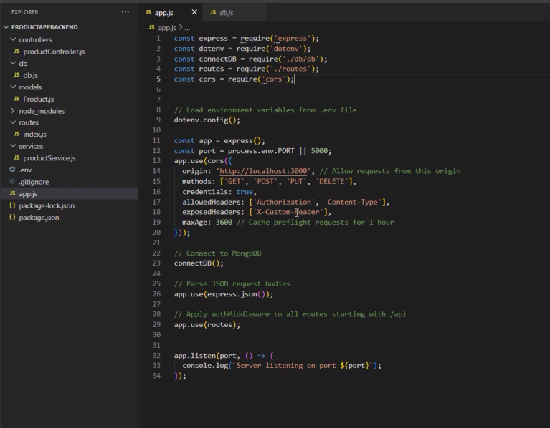

Frontend code:

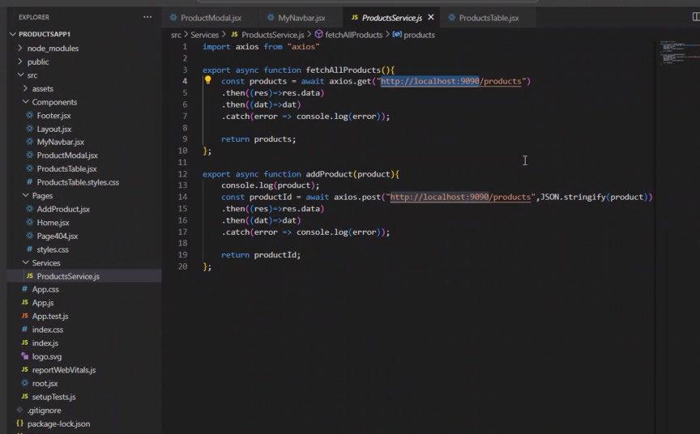





SSR – Server Side Rendering

CSR – Client Side Rendering

<https://nextjs.org/>

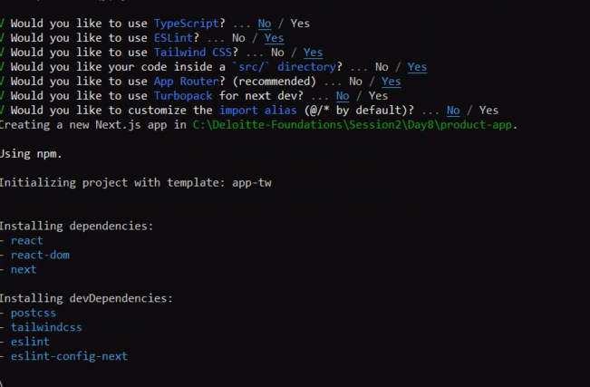

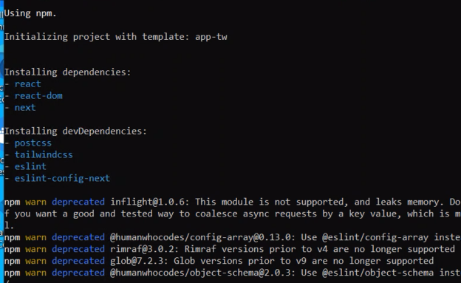

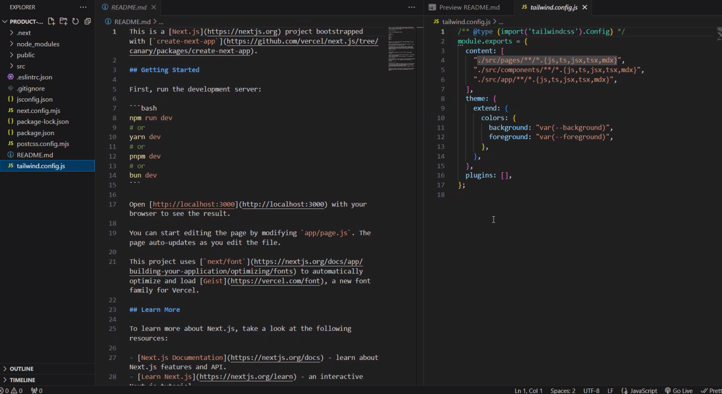

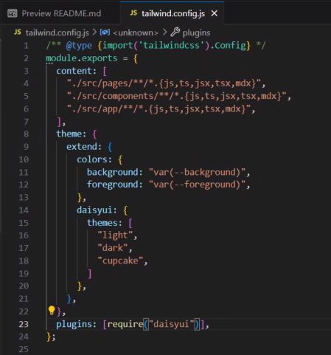

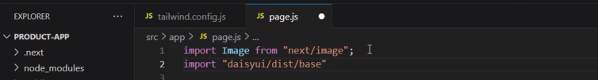

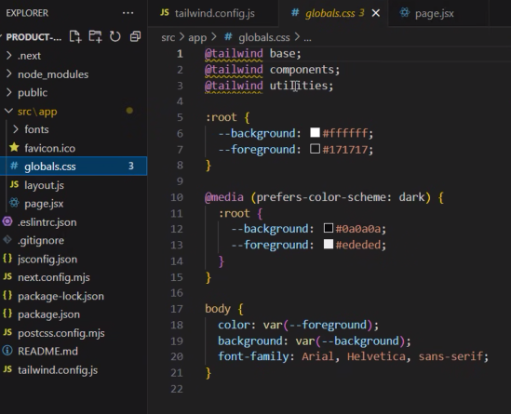

TAILWIND.CSS

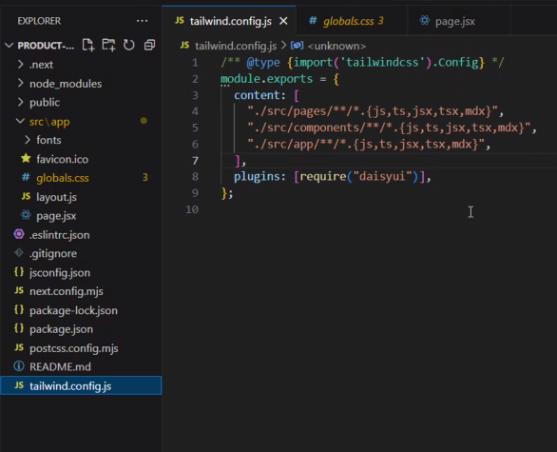

Page.jsx

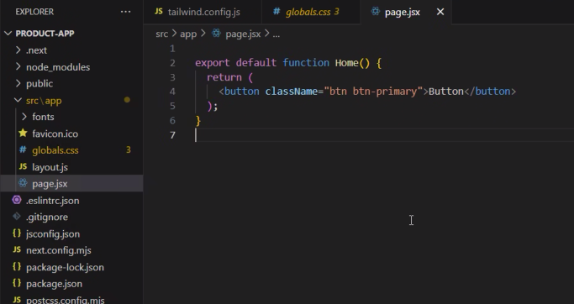

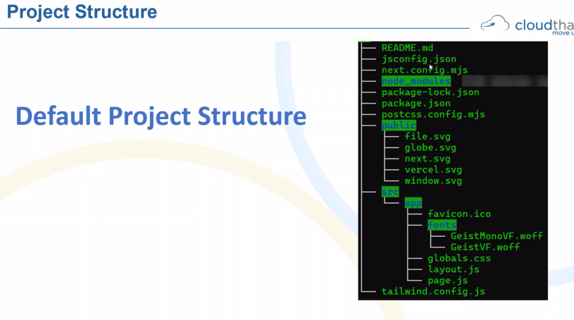

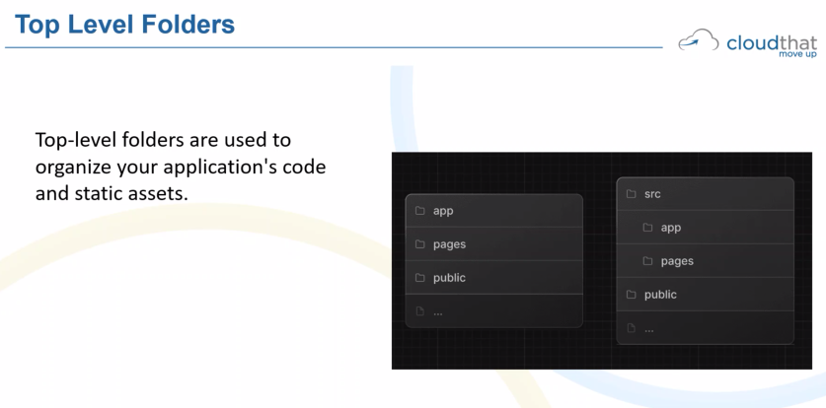

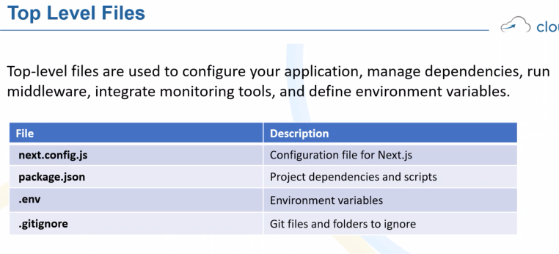

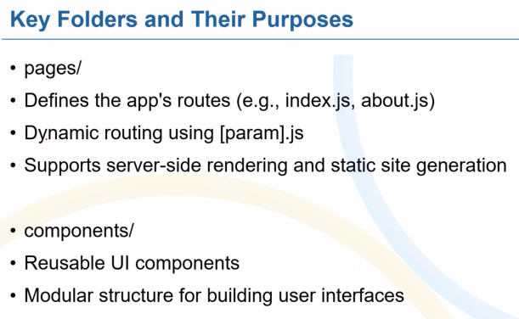

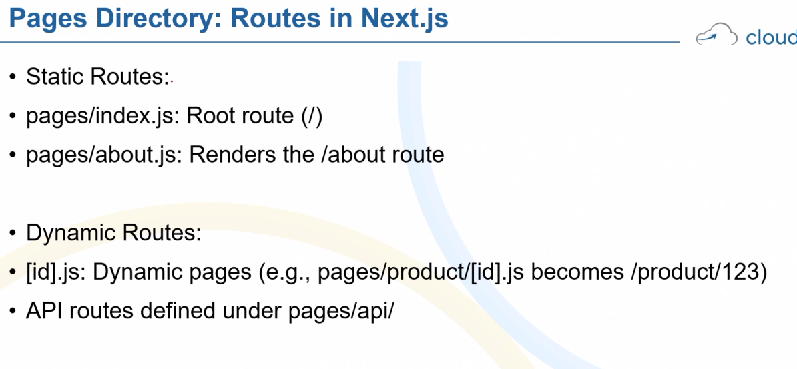

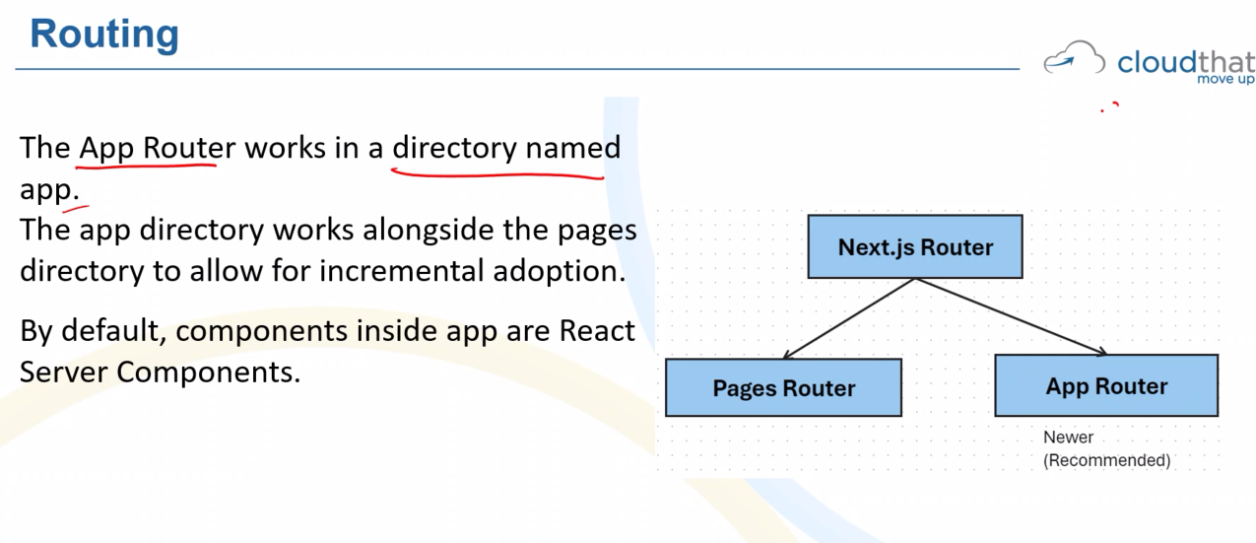

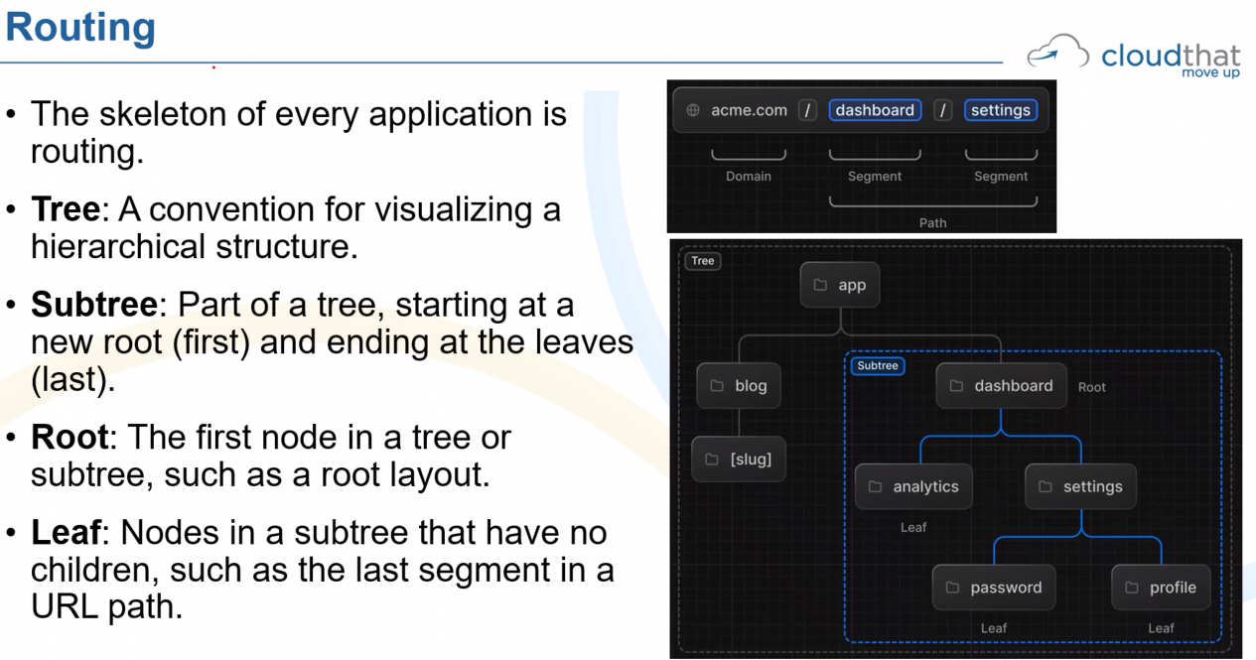

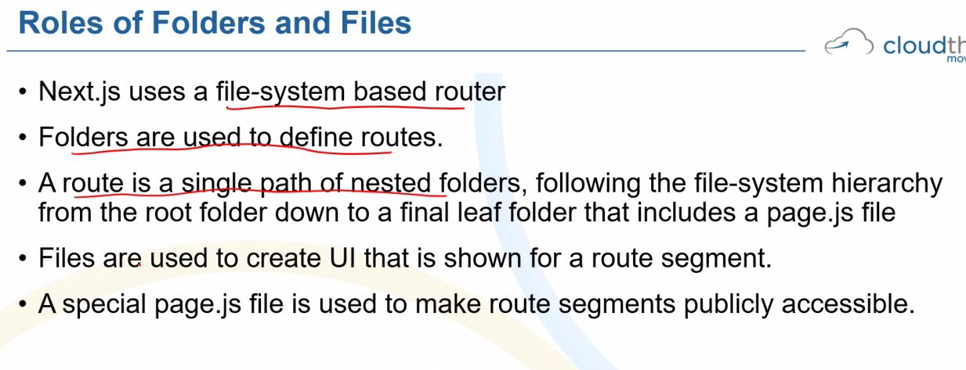

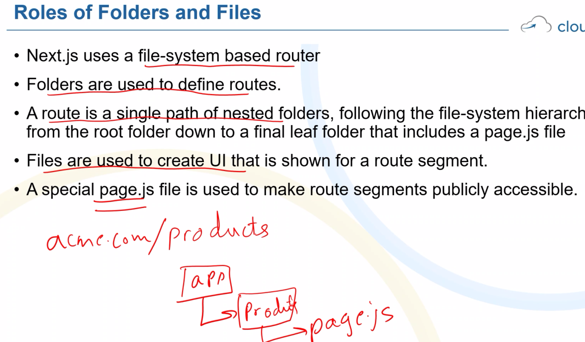

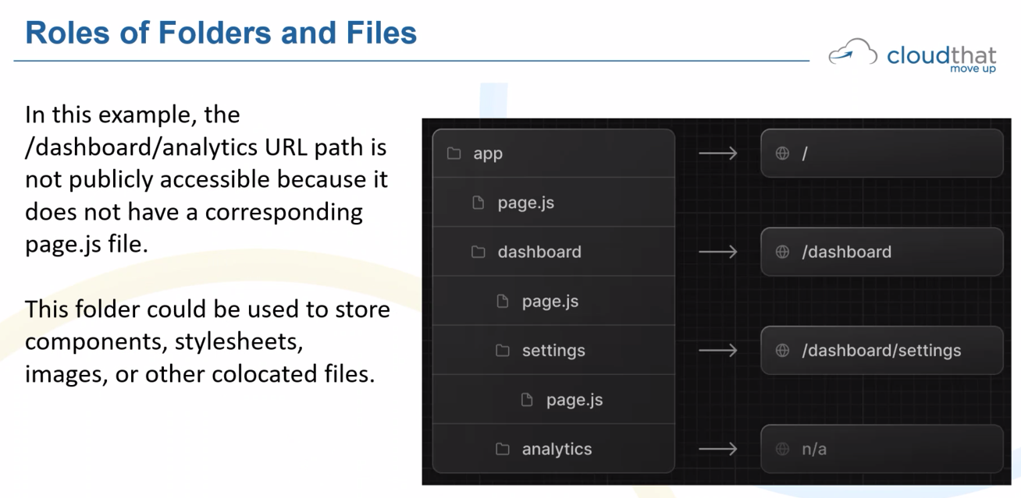

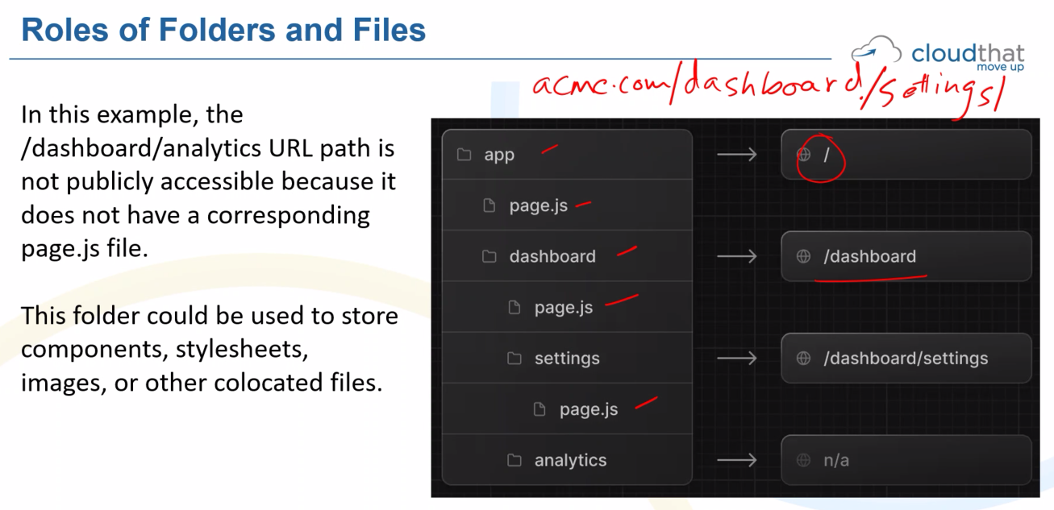

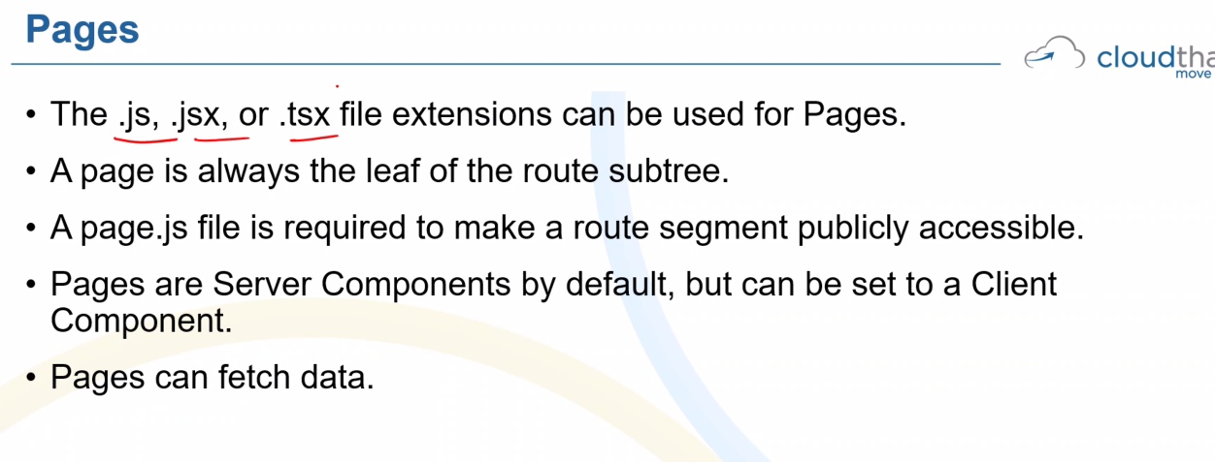

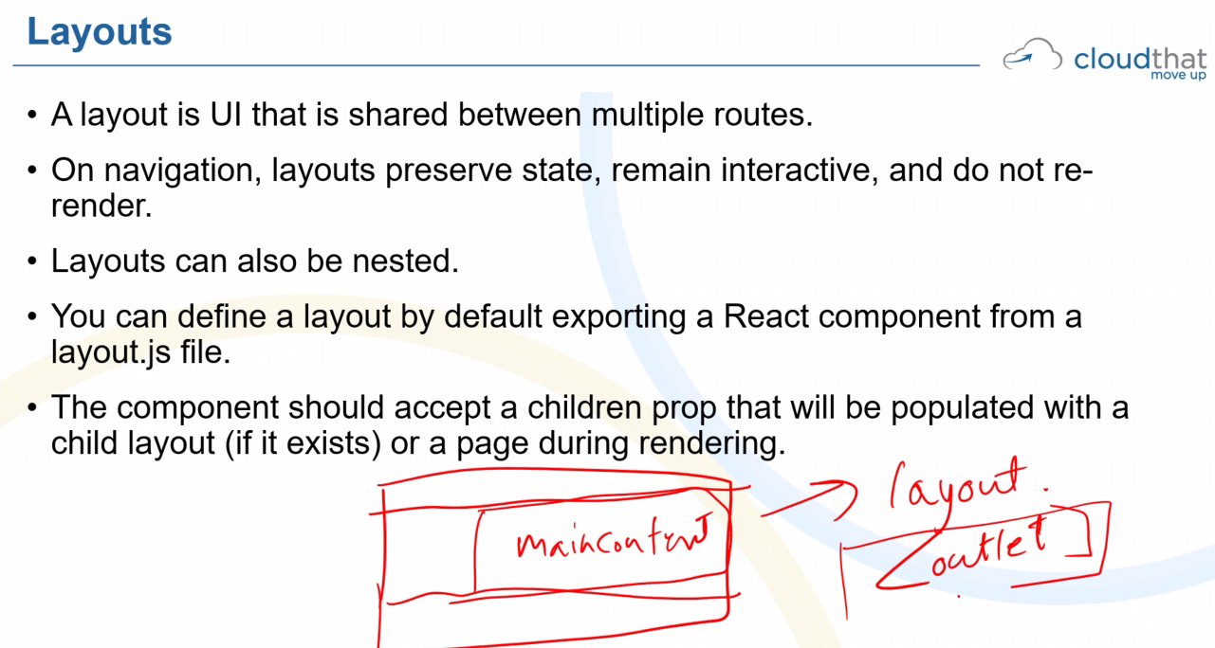

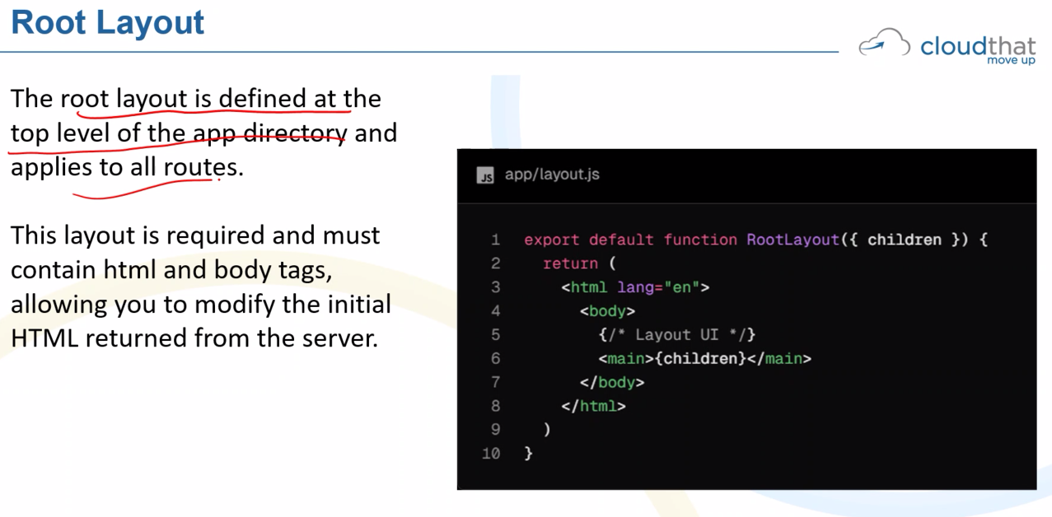

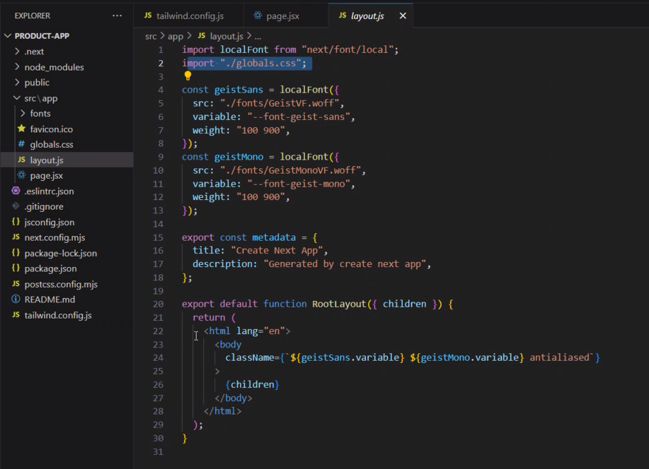

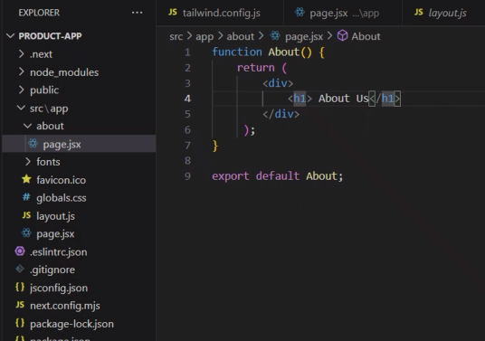

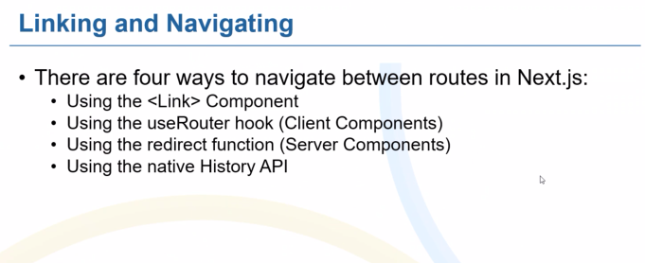

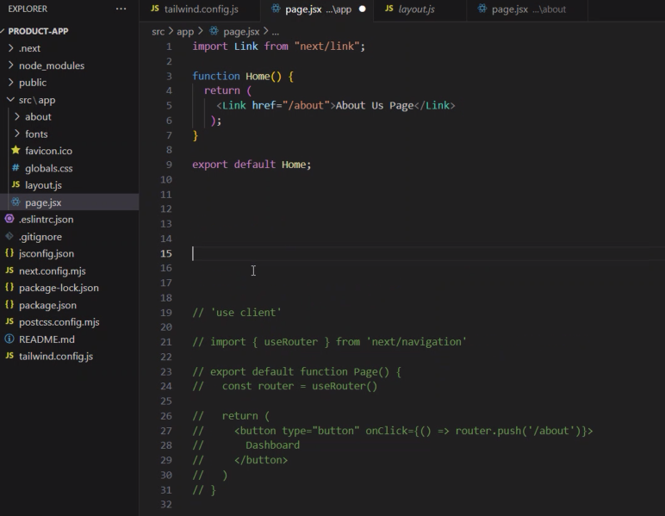

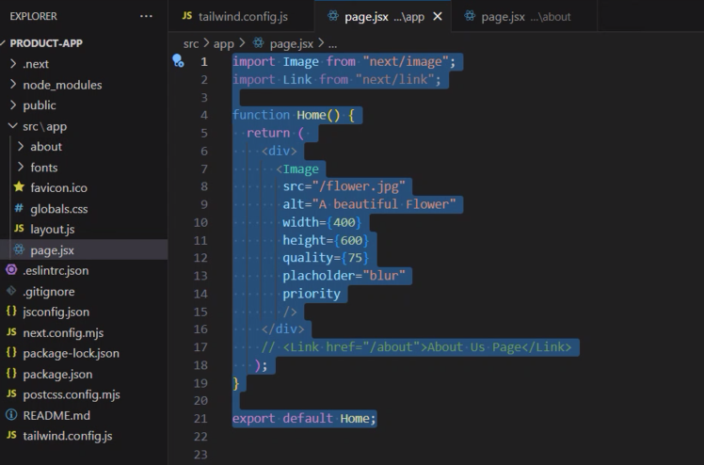

DAISYUI – User Interface library

Page.jsx (displaying a image)

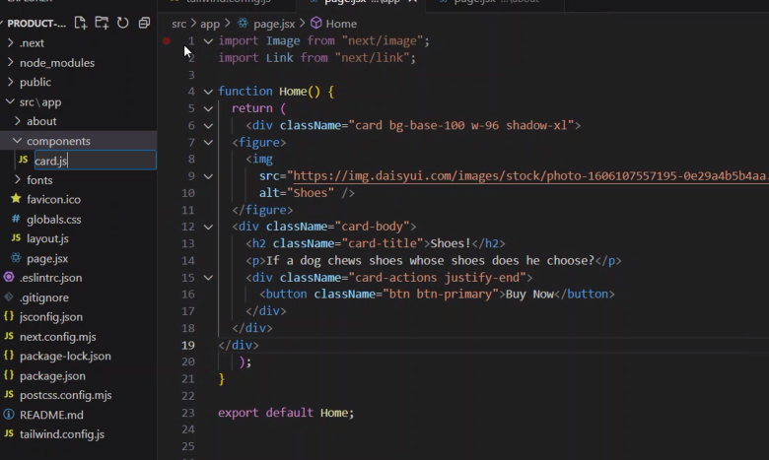

Src/app/components/card.jsx

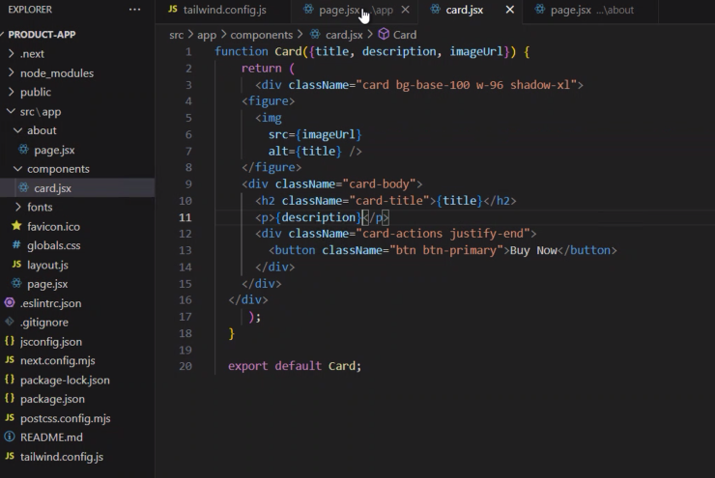

Cardcomponent

//Creating a card component

function Card({name, description, imageUrl}) {

    return (

      <div className="card bg-base-100 w-96 shadow-xl">

    <figure>

      <img

        src={imageUrl}

        alt={name} />

    </figure>

    <div className="card-body">

      <h2 className="card-title">{name}</h2>

      <p>{description}</p>

      <div className="card-actions justify-end">

        <button className="btn btn-primary">Buy Now</button>

      </div>

    </div>

  </div>

     );

  }

  export default Card;

//calling card component in home

import Card from "./components/card";

function Home() {

  const products = [

    {id:1,name:'Apple',description:'Kashmiri Apple',price:120,quantity:100, imageUrl: "[https://img.daisyui.com/images/stock/photo-1635805737707-575885ab0820.webp"](https://img.daisyui.com/images/stock/photo-1635805737707-575885ab0820.webp%22)},

    {id:2,name:'Banana',description:'Kashmiri Banana',price:120,quantity:100, imageUrl: "[https://img.daisyui.com/images/stock/photo-1635805737707-575885ab0820.webp"](https://img.daisyui.com/images/stock/photo-1635805737707-575885ab0820.webp%22)},

    {id:3,name:'Grapes',description:'Kashmiri Grapes',price:120,quantity:100,imageUrl: "[https://img.daisyui.com/images/stock/photo-1635805737707-575885ab0820.webp"](https://img.daisyui.com/images/stock/photo-1635805737707-575885ab0820.webp%22)},

    {id:4,name:'Mango',description:'Kashmiri Mango',price:120,quantity:0,imageUrl: "[https://img.daisyui.com/images/stock/photo-1635805737707-575885ab0820.webp"](https://img.daisyui.com/images/stock/photo-1635805737707-575885ab0820.webp%22)},

    {id:5,name:'Jackfruit',description:'Kerala Jackruit',price:120,quantity:0, imageUrl: "[https://img.daisyui.com/images/stock/photo-1635805737707-575885ab0820.webp"](https://img.daisyui.com/images/stock/photo-1635805737707-575885ab0820.webp%22)},

]

  return (

    <div>

      <h1>Displaying Multiple Cards</h1>

      <div>

        { products.map((product, idx)=>{

          <Card

          key={idx}

          title={product.name}

          description={product.description}

          imageUrl={product.imageUrl}

          />

        })

      }

      </div>

    </div>

   );

}

export default Home;

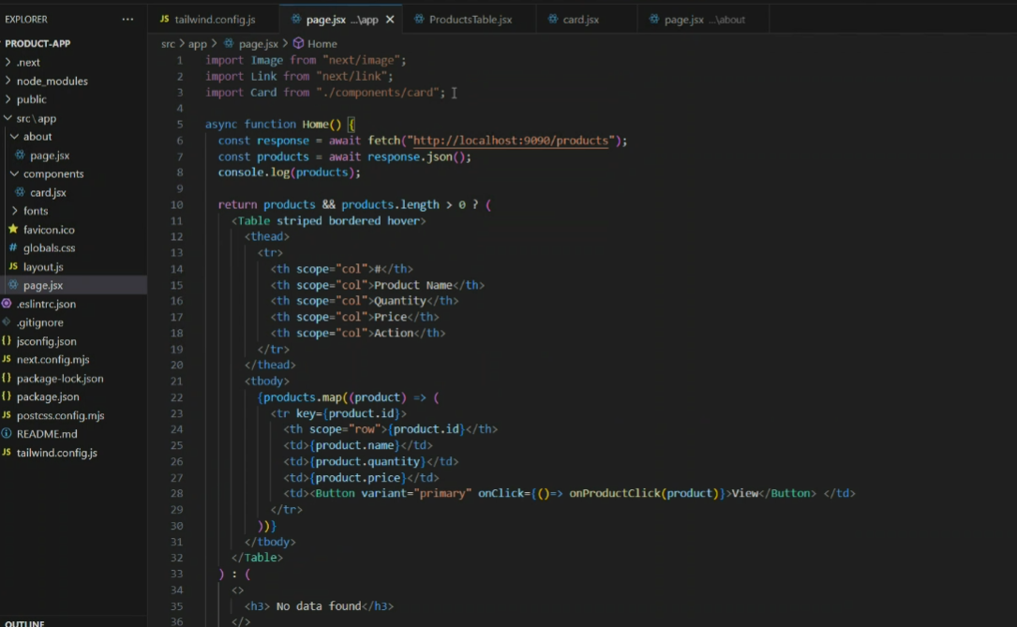

.env file connect to mongodb (the below code is used in yesterday session node.js)

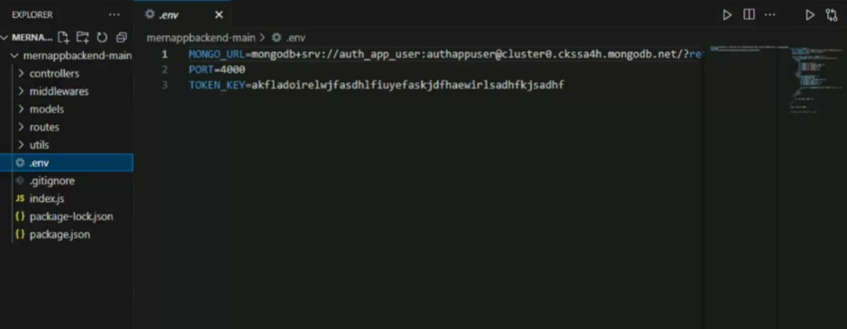

Next.js online documentation link

<https://nextjs.org/>

Tailwind css link:

<https://tailwindcss.com/>

DaisyUI link:

<https://daisyui.com/>

Lab: Complete the flow of products app with CRUD operation (React Bootstrap)

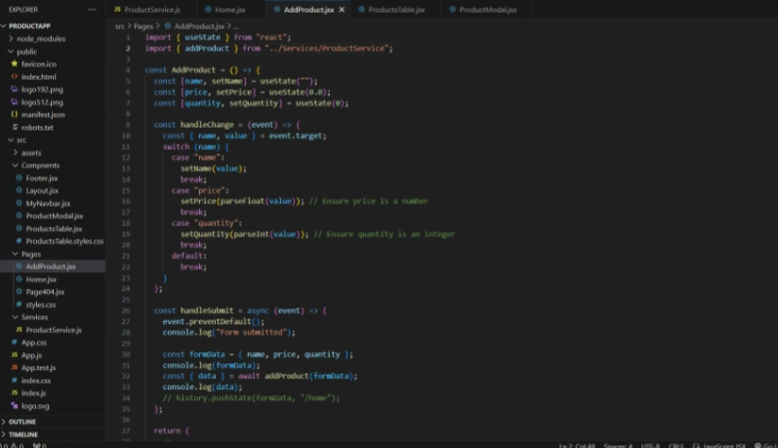

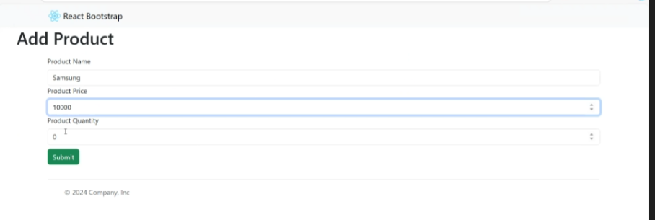

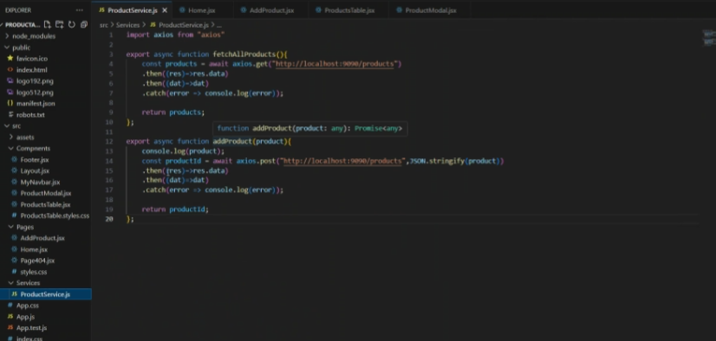

AddProduct.jsx

